Simran Shilky

9918103027

F1

**Assignment 7 Solution**

**Q1)# To print first and last 5 rows**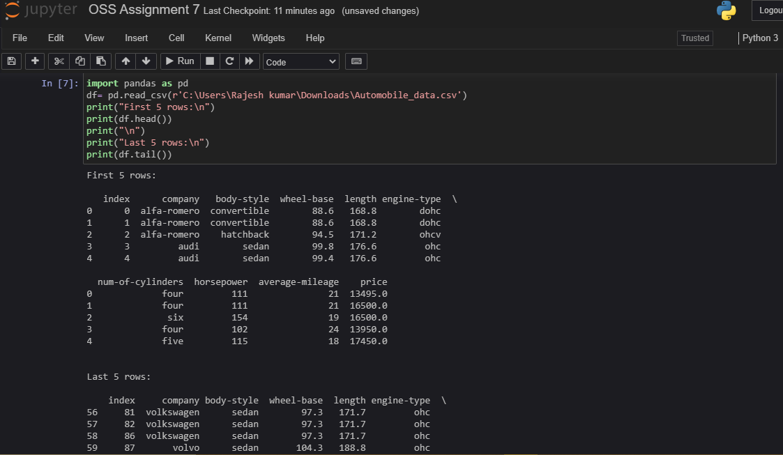

**Q2)# To replace ‘?’ to NaN**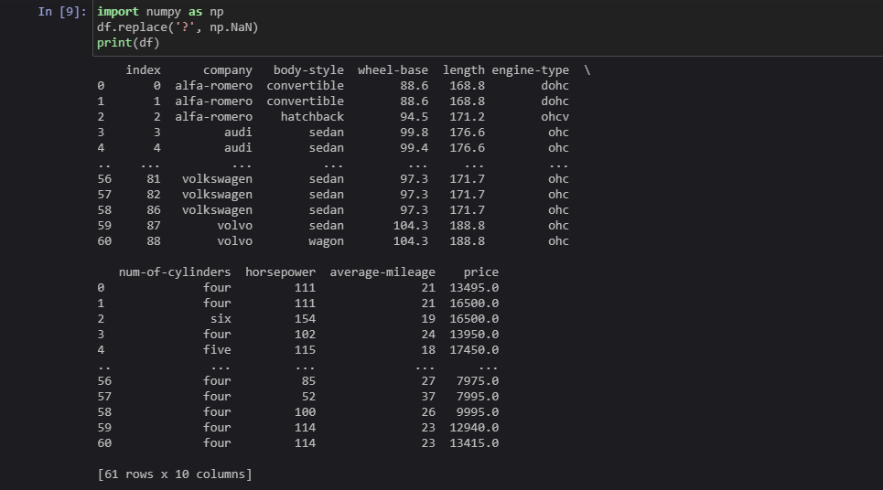

**Q3) # To print BMW details**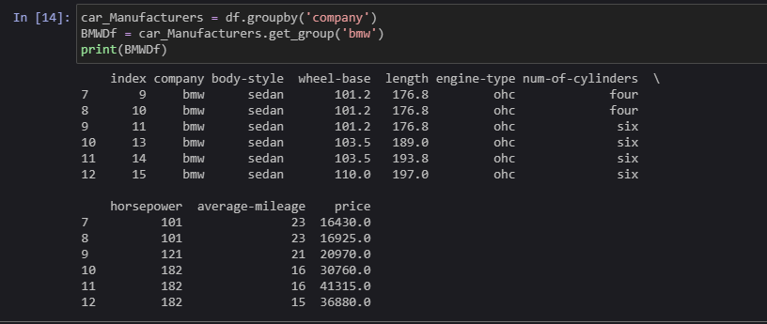

**Q4)# To print the total number of cars manufactured by each company**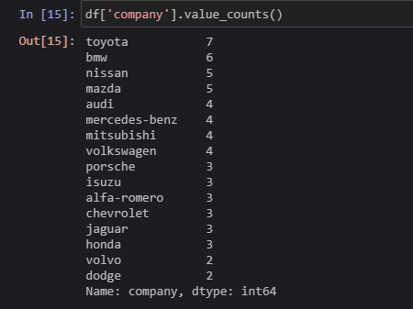

**Q5)# To print each company’s highest price car**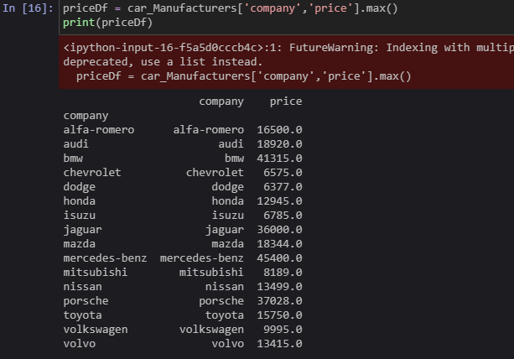

**Q6) # To find the average mileage of each company’s car**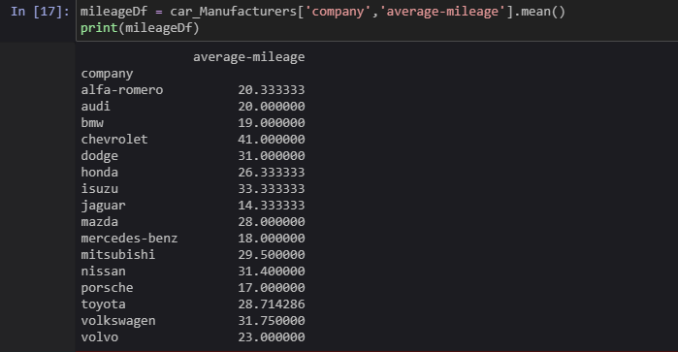

**Q7) #To merge two data frames based on a condition**